|  |
| --- |
|  |
| **Automotive Component Manufacturers Association Of India** |

**Press Release**

**Indian Automotive Industry in Crisis**

* ***Auto Component Industry grows by 14.5 per cent in 2018-19; Turnover Rs. 3.95 lakh crore (USD 57 billion)***
* ***Continued slowdown in the vehicle industry; immediate future worrisome***

**New Delhi; 24th July 2019**: Automotive Component Manufacturers Association of India (ACMA), the apex body representing India’s Auto Component manufacturing industry, today announced the findings of its Industry Performance Review for the fiscal 2018-19. The automotive component industry that contributes 2.3 per cent to India’s GDP, 25 per cent to its manufacturing GDP and provides employment to 50 lakh people, stood at Rs.3.95 lakh crore (USD 57 billion) for the period April 2018 to March 2019, registering a growth of 14.5 per cent over the previous year.

Commenting on the performance of the auto component industry in India, **Vinnie Mehta, Director General, ACMA** said*, “ The first-half of the fiscal 2018-19 witnessed a robust double digit growth, however the second-half saw a significant slump in vehicles sales. The component industry, in tandem, posted a some-what subdued performance with growth of 14.5 per cent over the previous fiscal, registering a turnover of Rs. 3,95,902 crore (USD 57 billion). Auto Component exports grew by 17.1 per cent in FY 2018-19 to Rs.106,048 crore (USD 15.16 billion)”.*

Speaking on the need for urgent government intervention to kick-start a long-term growth cycle for the Auto and Auto Component industry**, Ram Venkataramani, President, ACMA** said, *“The automotive industry is facing an unprecedented slowdown. The vehicle sales in all segments have continued to plummet for the last several months. Considering the auto component industry grows on the back of the vehicle industry, a current 15 to 20 per cent cut in vehicle production has led to a crisis like situation in the auto component sector. If the trend continues, an estimated ten-lakh people could be laid-off.”*

The subdued demand, recent investments made for transition from BSIV to BSVI, lack of a clarity on policy for electrification of vehicles, especially for two and three wheelers, has left the industry unsure of its future and has caused it to stop all future investments.

**Ram** further added, *“The industry needs urgent Government intervention. There is an immediate need to stimulate vehicle demand and also sustain it post BSVI implementation, as vehicles will become significantly expensive thereafter. We strongly recommend that the government instates 18% GST rate across the entire auto and auto component sector.”*

On the need for a stable policy for electric mobility **Ram** said*, “As we prepare for introduction of electric mobility in the country, the FAME 2 scheme and the associated Phased Manufacturing Program (PMP) are indeed welcome steps in this direction and will ensure a successful ‘Make in India’ program. Any further changes in targets for roll out of electric vehicles would increase India’s import bill and damage the current robust auto components manufacturing ecosystem. This will also result in significant job losses. Therefore, a stable, technology agnostic, e-mobility policy is the need of the hour to ensure a smooth transition and creation of a strong local supply base”.*

**Key findings of the ACMA Industry Performance Review 2018-19:**

* **Exports**: Exports of auto components grew by 17.1 per cent to Rs 106.048 crore (USD 15.16 billion) from Rs 90,571 crore (USD 13.4 billion) in 2017-18. Europe accounted for 33 per cent of exports followed by North America and Asia, with 29 per cent and 26 per cent respectively.
* The key export items included drive transmission & steering, engine components, Body/Chasis, Suspension & Braking etc.
* **Imports**: Imports of auto components increased by 14.4 per cent to Rs.1,23,688 crore (USD 17.6 billion) in 2018-19 from Rs.106,672 crore (USD 15.9 billion) in 2017-18. Asia accounted for 61 per cent of imports followed by Europe and North America, with 29 per cent and 8 per cent respectively.

* **Aftermarket**: With increasing vehicle base in the country, the aftermarket in 2018-19 grew by 9.6 per cent to Rs 67,491 crore (USD 10.1 billion) from Rs.61,601 (USD 9.2 billion) in the previous fiscal.

**INDIAN AUTO COMPONENT INDUSTRY- ANNUAL TURNOVER & GROWTH**

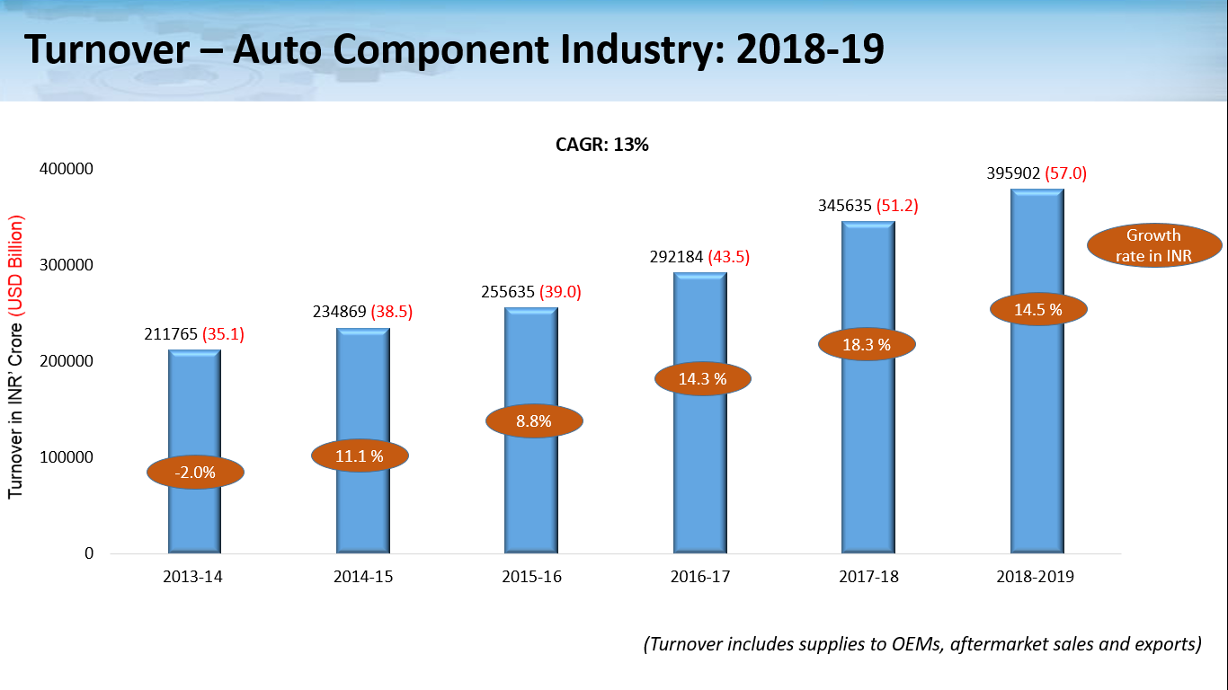

**Summary of Findings:**

*Figures in INR Crore*

|  |  |  |  |  |  |  |
| --- | --- | --- | --- | --- | --- | --- |
|  | **2013-2014** | **2014-2015** | **2015-2016** | **2016-2017** | **2017-2018** | **2018-19** |
| Turnover | 211,765 | 234,869 | 255,635 | 292,184 | 345,635 | 395,902 |
| Growth% | -2.00% | 11.10% | 8.80% | 14.30% | 18.30% | 14.5% |
| Exports | 61,487 | 68,522 | 70,916 | 73,128 | 90,571 | 106,048 |
| Growth% | 16.70% | 11.40% | 3.50% | 3.10% | 23.90% | 17.1% |
| Imports | 77,160 | 82,931 | 90,662 | 90,571 | 106,672 | 123,688 |
| Growth% | 3.60% | 7.50% | 9.30% | -0.10% | 17.80% | 16% |
| Aftermarket | 35,603 | 39,875 | 44,660 | 56,096 | 61,601 | 67,491 |
| Growth% | 12.00% | 12.00% | 12.00% | 25.60% | 9.8 | 9.6% |

*Figures in USD Billion*

|  |  |  |  |  |  |  |
| --- | --- | --- | --- | --- | --- | --- |
|  | **2013-2014** | **2014-2015** | **2015-2016** | **2016-2017** | **2017-2018** | **2018-19** |
| Turnover | 35.1 | 38.5 | 39 | 43.55 | 51.2 | 57.0 |
| Growth% | -11.50% | 9.60% | 1.30% | 11.70% | 18.30% | 14.5% |
| Exports | 10.2 | 11.22 | 10.81 | 10.9 | 13.5 | 15.16 |
| Growth% | 5.40% | 10.00% | -3.70% | 0.80% | 24% | 12.5% |
| Imports | 12.8 | 13.58 | 13.82 | 13.5 | 15.9 | 17.6 |
| Growth% | -6.40% | 6.10% | 1.80% | -2.30% | 17.8% | 11% |
| Aftermarket | 5.9 | 6.5 | 6.8 | 8.4 | 9.2 | 10.1 |
| Growth% | 1.10% | 10.70% | 4.00% | 23.50% | 9.50% | 9.8% |

Note:

*Turnover data represents the entire supplies from the auto component industry (ACMA members and non-members) to the on-road and off-road vehicle manufacturers and the aftermarket in India as well as exports. This also includes component supplies captive to the OEMs and by the unorganized and smaller players.*

**About ACMA:**

The Automotive Component Manufacturers Association of India (ACMA) is the apex body representing the interest of the Indian Auto Component Industry. Its membership of over 830 manufacturers contributes more than 90% of the auto component industry’s turnover in the organized sector. ACMA is an ISO 9001:2015 Certified Association. ACMA has played a pivotal role in supporting its members in export development and in discovering new market opportunities, currently the industry exports to more than 160 countries.

.

**For further details:**

|  |  |
| --- | --- |
| **ACMA**  Upender Singh / E: [upender.singh@acma.in](mailto:upender.singh@acma.in) / M: 9990125916  Sushil Rajput / [sushil.rajput@acma.in](mailto:sushil.rajput@acma.in) / M: 9650176419 | **Avian Media**  Saurabh Gupta | M: 9818075578 | E: saurabhgupta@avian-media.com  Mili Anand | M: 9560577831 | E: [mili@avianwe.com](mailto:mili@avianwe.com) |