cid:b358cc71b24407be_0.0.1

**REGISTRATION FORM**

**ACMA** Scanned form to be sent: [**sapna.vijh@acma.in**](mailto:sapna.vijh@acma.in)

**6TH Floor,**  Mobile No. : +91-9873369063

**The Capital Court, Olof Palme Marg,**

**Munirka, New Delhi – 110067**

Dear Sir,

Our Company \_\_\_\_\_\_\_\_\_\_\_\_\_\_\_\_\_\_\_\_\_\_\_\_\_\_\_\_\_\_\_\_\_\_\_\_confirms participation at **Auto Technology Partnership Summit – The India Opportunity from 2-5 February, 2021**, and would like to nominate the following personnel from our organisation.

Name\* Designation\* E-mail id\* Mobile Number\*

\_\_\_\_\_\_\_\_\_\_\_\_\_\_\_\_ \_\_\_\_\_\_\_\_\_\_\_\_\_\_\_\_\_\_\_\_ \_\_\_\_\_\_\_\_\_\_\_\_\_\_\_\_\_\_\_ \_\_\_\_\_\_\_\_\_\_\_\_\_\_\_

**Products Manufactured\*:**

**Products for Partnering \* (please mention below):**

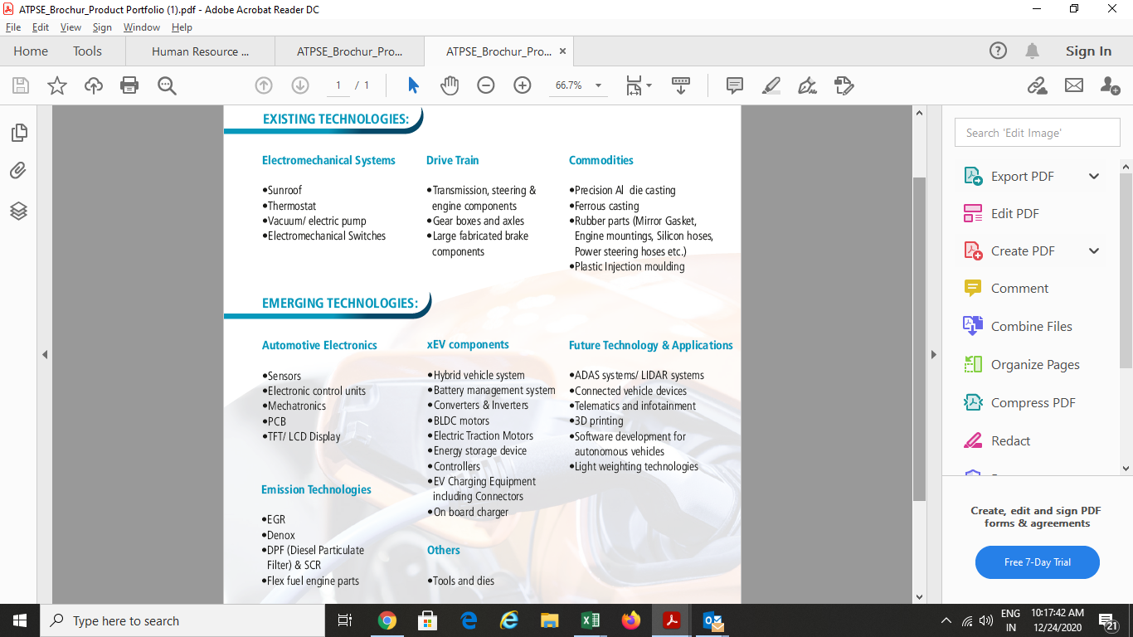

|  |  |  |  |
| --- | --- | --- | --- |
| **S. No.** | **Type of Collaboration** | **Please tick (Any 2)** | **Area of interest with product group** |
| 1 | Seeking Technical Collaboration/ Joint venture |  |  |
| 2 | Explore export Opportunities |  |  |
| 3 | Seeking opportunity for other tie up (Contract manufacturing/ M&A) |  |  |
| 4 | Collaboration for EV components/ next generation mobility solutions |  |  |

**Please provide us with the following information of the company\*:**

IEC CODE: \_\_\_\_\_\_\_\_\_\_\_\_\_\_\_\_\_\_\_\_\_\_; PAN NO: \_\_\_\_\_\_\_\_\_\_\_\_; DIN NO: \_\_\_\_\_\_\_\_\_\_\_\_\_\_\_\_\_\_\_

**Cost of Participation: Annexure I**

**Sponsorship:** Rs. 75,000/-

(Includes premium booth and logo branding in all marketing collaterals including International)

**Premium Booth 3D Product Display:** Rs. 29,500/- (Inclusive of GST)

**Standard Booth 2D Product Display:** Rs. 23,600/- (Inclusive of GST)

**Bank Details:**

|  |  |  |
| --- | --- | --- |
| DEMAND DRAFT / CHEQUE NO. \_\_\_\_\_\_\_\_\_\_\_\_\_\_\_Dated\_\_\_\_\_\_\_\_\_\_\_\_\_\_\_  AMOUNT: \_\_\_\_\_\_\_\_\_\_\_\_\_\_\_  (NON-REFUNDABLE)  TDS:\_\_\_\_\_\_\_\_\_\_\_\_\_\_\_\_\_\_\_\_ BANK:\_\_\_\_\_\_\_\_\_\_\_\_\_\_\_\_\_\_  DATED: \_\_\_\_\_\_\_\_\_\_\_\_\_\_\_\_\_  IN FAVOUR OF "AUTOMOTIVE COMPONENT MANUFACTURERS ASSOCIATION OF INDIA" | | ACMA Bank detail for bank transfer :  Bank Account Name : Automotive Component Manufacturers Association of India  Account No. : 90561010001459  Bank Account Type: Current  Bank Name: Syndicate Bank  Bank Address: R.K.Puram, Delhi Tamil Sangam Buidling, New Delhi-110022, India  SWIFT Code: SYNBINBB126  MICR Code: 110025043  IFSC Code : SYNB0009009  UTRNO. \_\_\_\_\_\_\_\_\_\_\_\_\_\_\_\_\_ DATE:\_\_\_\_\_\_\_\_\_\_\_  AMOUNT:\_\_\_\_\_\_\_\_\_\_\_\_\_\_\_ TDS\_\_\_\_\_\_\_\_\_\_\_\_\_\_ |
| Invoicing Details | | | |
| Name |  | | |
| Designation |  | | |
| Company |  | | |
| Address on Invoice |  | | |
| Mobile no. |  | | |
| GST Number as per Invoice Address |  | | |

Coordinator’s Name\*: \_\_\_\_\_\_\_\_\_\_\_\_\_\_\_\_\_\_\_\_\_\_\_\_\_\_\_\_\_\_\_\_\_\_\_\_\_Designation\*: \_\_\_\_\_\_\_\_\_\_\_\_\_\_\_\_\_\_\_\_\_\_\_\_\_\_\_\_

Organisation\*: \_\_\_\_\_\_\_\_\_\_\_\_\_\_\_\_\_\_\_\_\_\_\_\_\_\_\_\_\_\_\_\_\_\_\_\_\_\_\_\_\_\_\_\_\_\_\_\_\_\_\_\_\_\_\_\_\_\_\_\_\_\_\_\_\_\_\_\_\_\_\_\_\_\_\_\_\_\_\_\_\_\_

Address\*: \_\_\_\_\_\_\_\_\_\_\_\_\_\_\_\_\_\_\_\_\_\_\_\_\_\_\_\_\_\_\_\_\_\_\_\_\_\_\_\_\_\_\_\_\_\_\_\_\_\_\_\_\_\_\_\_\_\_\_\_\_\_\_\_\_\_\_\_\_\_\_\_\_\_\_\_\_\_\_\_\_\_\_\_\_

Tel. No\*: \_\_\_\_\_\_\_\_\_\_\_\_\_\_\_\_\_\_\_\_\_\_\_\_\_\_\_\_\_\_\_\_\_\_\_\_\_\_\_ Fax No: \_\_\_\_\_\_\_\_\_\_\_\_\_\_\_\_\_\_\_\_\_\_\_\_\_\_\_\_\_\_\_\_\_\_\_\_\_\_\_

Mobile No\*: \_\_\_\_\_\_\_\_\_\_\_\_\_\_\_\_\_\_\_\_\_\_\_\_\_\_\_\_\_ E-Mail id\*: \_\_\_\_\_\_\_\_\_\_\_\_\_\_\_\_\_\_\_\_\_\_\_\_\_\_\_\_\_\_\_\_\_\_\_\_\_\_\_\_\_\_\_\_\_

Signature: ­­­­­­­­­­­­­­­­­­­­­­­­­­­­­­­­­­­\_\_\_\_\_\_\_\_\_\_\_\_\_\_\_\_\_\_\_\_\_\_\_\_\_\_\_\_\_\_ Date\*: \_\_\_\_\_\_\_\_\_\_\_\_\_\_\_\_\_\_\_\_\_\_\_\_\_\_\_\_\_\_\_\_\_\_\_\_\_\_\_\_\_\_\_\_\_\_\_\_\_

* Fields marked with \* are mandatory.
* The participation fee is non-refundable, however change in Nomination is allowed till two days before the program date.
* Re-Confirmation email will be sent by ACMA.